**Git and GitHub tutorial.**

This tutorial assumes that the user has already downloaded and installed Git and GitHub, made an account with GitHub, and has access to a repository.

1. 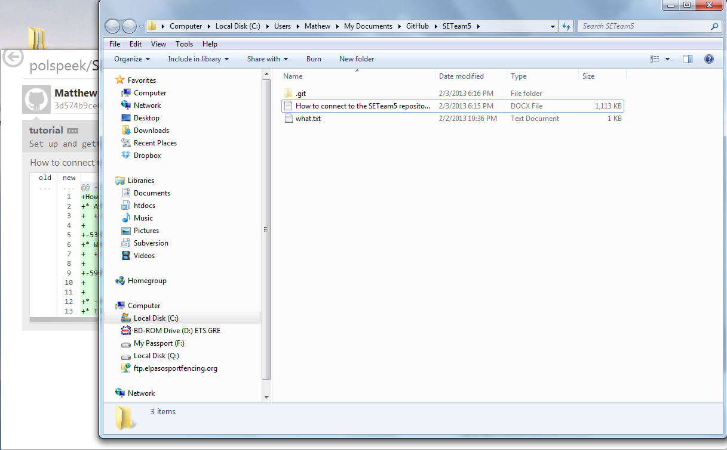**Create and upload files**. When the user has cloned and opened his/her repository there is a folder created usually in MyDocuments>GitHub>’Name of Repo’. In it there is a hidden folder called ‘.git’. It is in this folder where all files in the repo will be stored and accessed.
2. **Committing files**. Once the user has saved a file in the repo folder, the user should return to the GitHub gui. There the user will be prompted to commit all uncommitted changes.



The user must enter a description in the yellow box to commit. Also, there is an addition field for more details on the file.

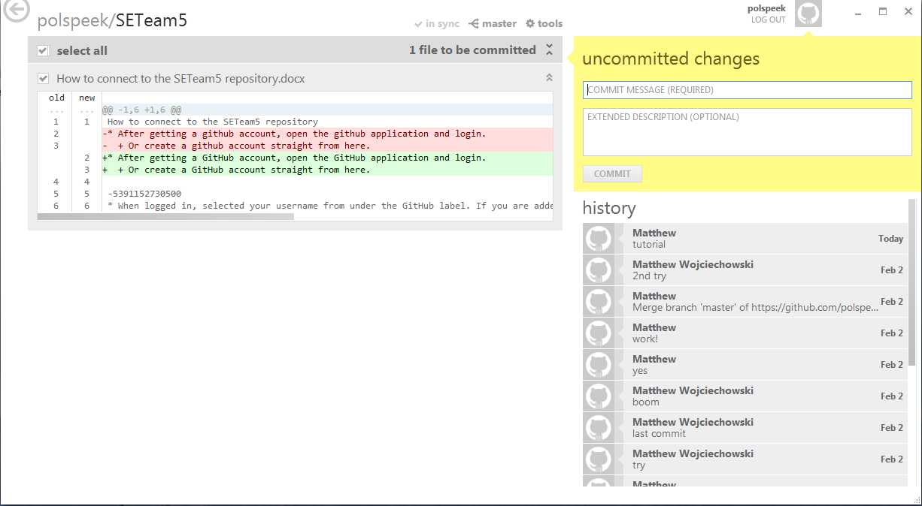

1. **Syncing**. When all the uncommitted changes are committed it is necessary to sync the repo. There is a sync button on the top of the page. When the user clicks on that, the repo will begin to sync.

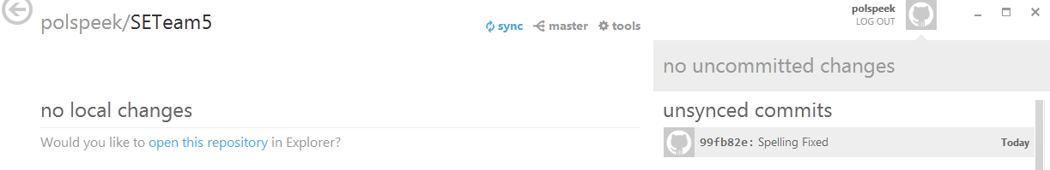

If successful, the button will change to “in sync”. Now all the new files and changes will be available to all users of the repo. 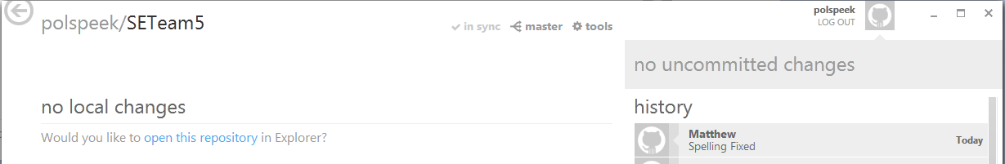

1. **Refreshing**. The repo will not re-sync automatically. The user must sync, or press F5 to refresh, to obtain any new changes to the repository.
2. **History**. On the right side of the page there is a list of all the changes that have happened to the repo. These include: what changes were done, who committed the changes and when the changes were committed.

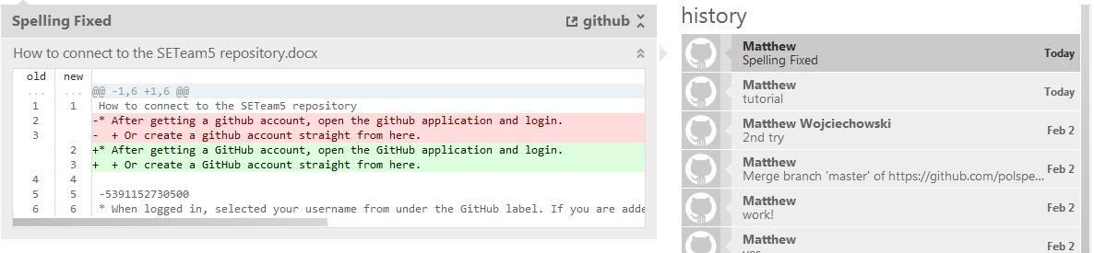

1. **Tools**. There is an icon on the top of the page called “Tools”. Clicking on that will bring up a menu that allows you open the repo folder, open a shell (cmd), and goto GitHub.com and view the repo there.

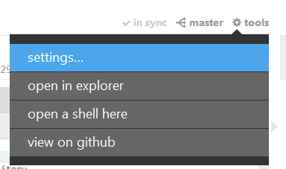

1. **Branching**. Git works off of branching and merging. What this means is that the user can checkout a new branch of the repo and work on his/her stuff in that branch and committing will have no effect on other user checkouts of the repo.
   1. To create a branch, the user should click the button called “master” at the top of the page and enter the name of the new branch the user wants.

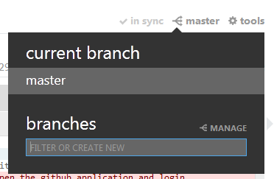

* 1. To merge the new branch back to the master branch, click the “new branch” icon (previously ‘master’) and select manage. Then drag the new branch to the bottom of the page where it says merge. Drag the master branch to the 2nd slot. Select merge. The branches should be merged into the master branch. 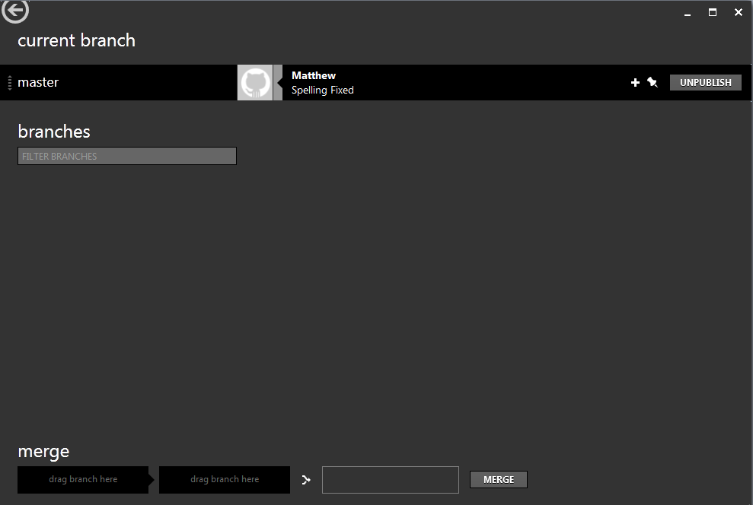

1. **Command Prompt**. GitHub and Git rely heavily on the command prompt.
   1. To open the cmd, click on Tools and select open shell.
   2. Here you can type in commands that will do most and more of the stuff that is available through the gui.
   3. Two reference pages for cmd commands: <http://www.siteground.com/tutorials/git/commands.htm> and

<http://gitref.org/>

